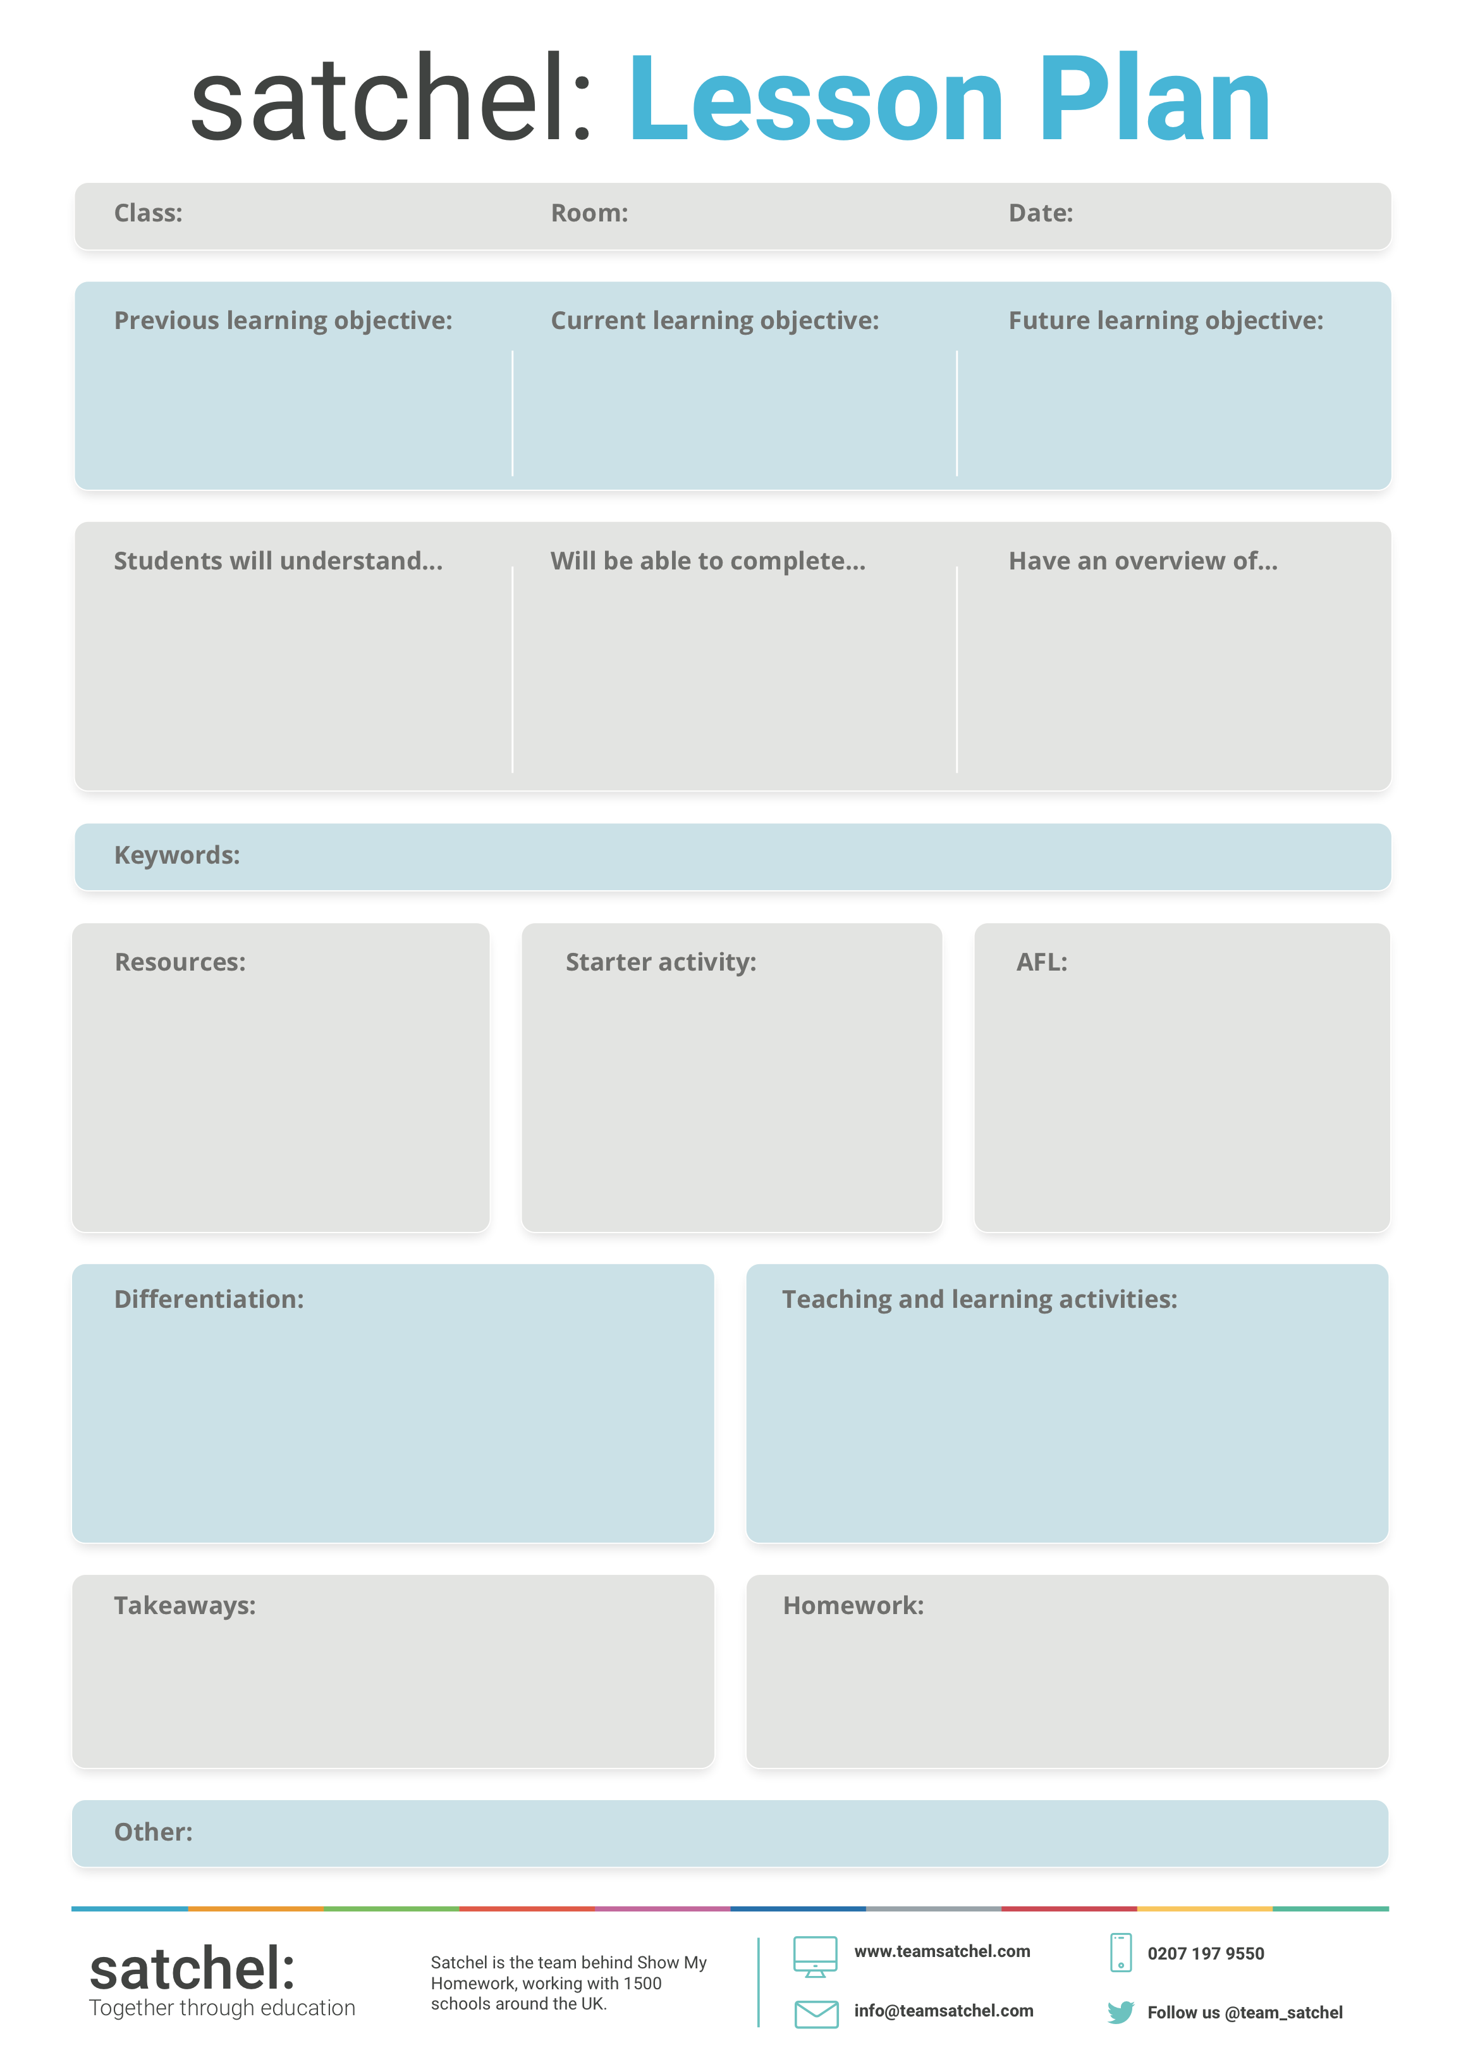

Room for anything else that crops up!

How can this be adapted for different learning abilities? Is there an element of choice? Is there a must do, should do, could do? Is there EAL/SEN/PP differentiation?

You can have as many of these as you wish and they may be teacher-led or student-led.

What should students take away from this lesson?

Is there a homework activity for independent learning?

Link back to learning objectives - how will students know they have understood and applied what they are meant to?

Something to get the students’ attention and spark curiosity - create a buzz around a topic and get them ready for collaboration.

Do you need textbooks, worksheets, or videos?

Do you have access to a TA?

Pick a few keywords for students to learn

Students could

Students should

Students must

Insert text here…

Insert text here…

Insert text here…

Room number

01/10/2017

Class name